**Contents:**

**1.** **Introduction:** 2

**2.** **Origins and Biblical Foundation** 2

**3.** **Early Christian Period:** 3

**4.** **Medieval Church Practices:** 3

**5.** **Cultural and Legal Recognition:** 3

**6.** **Conclusion** 3

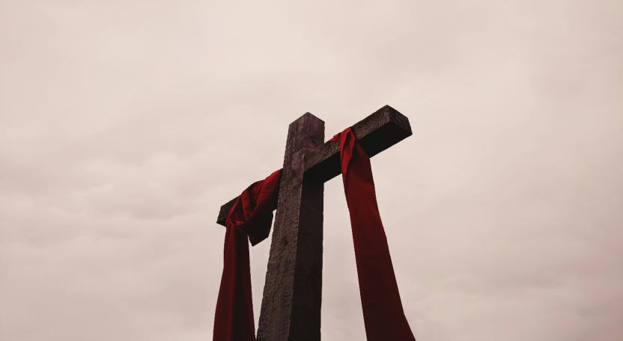

# **Introduction:**

Good Friday is one of the most solemn and significant days in the Christian calendar. Observed during Holy Week, it commemorates the crucifixion of Jesus Christ and his death at Calvary. It is a day of mourning, reflection, and prayer, marking the culmination of Jesus’ Passion and a pivotal moment in Christian theology.

# **Origins and Biblical Foundation**

The term "Good Friday" is believed to have originated from the phrase “God’s Friday,” although the exact etymology is debated. Despite the sorrowful nature of the day, it is called "good" because of the belief that Jesus’ death led to the salvation of humanity.

The events commemorated on Good Friday are documented in the New Testament Gospels—Matthew, Mark, Luke, and John. These accounts describe how Jesus was betrayed by Judas Iscariot, arrested, tried before Pontius Pilate, and sentenced to death by crucifixion.

# **Early Christian Period:**

In the first few centuries of Christianity, Good Friday was observed with fasting and prayer but without formal liturgies. By the 4th century, the Church began developing more structured observances, often tied to the Jewish Passover calendar.

# **Medieval Church Practices:**

During the Middle Ages, Good Friday services became more elaborate. The veneration of the cross, the reading of the Passion narrative, and solemn processions became integral parts of the day. The Roman Catholic Church and Eastern Orthodox Church both developed distinct liturgical traditions.

# **Cultural and Legal Recognition:**

Good Friday is a public holiday in many countries including:

* United Kingdom
* Canada
* Australia
* Germany
* India (in many states)
* South Africa

However, it is not a federal holiday in the United States, although it is observed in some states.

# **Conclusion**

Good Friday stands as a powerful reminder of love, sacrifice, and redemption in the Christian faith. It invites reflection on the suffering of Christ and the profound implications of his death. As such, it continues to be observed with deep reverence by millions of Christians around the world. Many churches hold afternoon services between noon and 3:00 PM, marking the hours of Jesus' suffering on the cross. A devotional practice where believers meditate on 14 events from Jesus' condemnation to his burial.